Experimental Validation
The Motor Imagery (MI) BCI FII corpus is used to validate the Julia implementation of the Riemannian Minimum Distance to mean (MDM) classifier in PosDefManifold.jl against the reference implementations in Python (PyRiemann). The classification accuracy and the execution time in the two implementations is compared.
Two MI classification tasks are considered:
1) “right hand” vs. “feet”,
2) “left hand” vs. “right hand”.

Classification Accuracy
The pre-processing and encoding have been carried-out separately in the two languages. For each session in all databases, an 8-fold cross-validation has been performed using the StratifiedKFold function of the Python Scikit-learn package to extract the training and validation splits, which have been used identically in both languages. This ensures that exactly the same splits are used in the two languages.

Pre-processing
Pass-band 4th-order linear-phase response (forward-backward) Butterworth digital filter in the region 8Hz-32Hz.

Encoding
Sample covariance matrix estimation of the MI trials with a Tikhonov regularization (diagonal loading) with parameter 10e-4.

Model fitting and prediction
Riemannian MDM (nearest centroid).
Table 1: Resources for the implementation in Julia and Python
Implementation | Julia | Python
Pre-processing | DSP.jl (from Eegle.jl) | SciPy
Encoding | Eegle.jl | PyRiemann
Model fitting and prediction | PosDefManifoldML.jl | PyRiemann

Results
1) “right hand” vs “feet”
Table 2: Classification accuracy for “right hand” vs. “feet” MI
Database | Julia Mean and Std (%) | Python Mean and Std (%) | Difference of Means
AlexMI-None | 74.99 ± 14.90871 | 75.0 ± 14.9092 | -0.009375
BNCI2014001-None | 84.94 ± 11.90432 | 84.95 ± 11.9096 | -0.011944
BNCI2014002-Test | 78.98 ± 17.0275 | 78.98 ± 17.03021 | -0.001179
BNCI2014002-Train | 76.18 ± 11.3729 | 76.17 ± 11.36971 | 0.005857
BNCI2015001-None | 81.11 ± 12.84454 | 81.1 ± 12.8419 | 0.001214
Schirrmeister2017-None | 86.3 ± 13.98145 | 86.29 ± 13.98154 | 0.005071
Weibo2014-None | 75.66 ± 10.0781 | 75.65 ± 10.07801 | 0.0005
Zhou2016-None | 87.85 ± 5.3869 | 87.84 ± 5.38551 | 0.009591

Figure 1: Classification accuracies for “right hand” vs. “feet” MI. Each point is a session. Points lying on the horizontal dashed lines indicate a null difference of the accuracy obtained in the two languages.
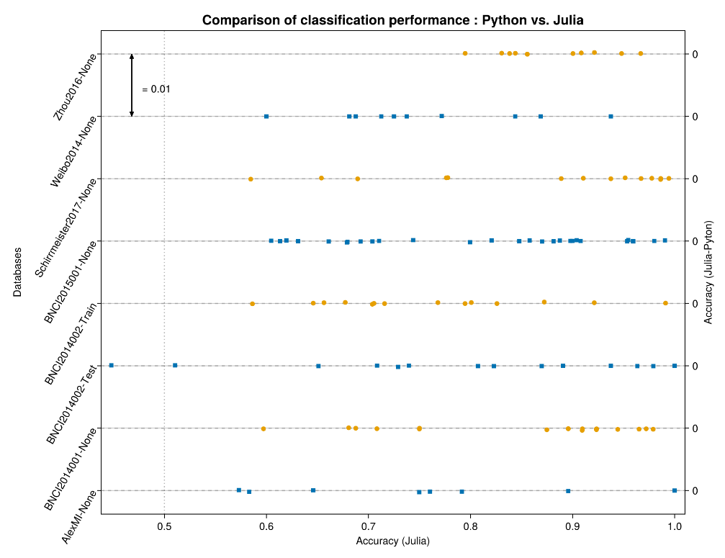

2) “left hand” vs. “right hand”.

Table 3: Classification accuracy for left hand vs. right hand MI
Database | Julia Mean and Std (%) | Python Mean and Std (%) | Difference
BNCI2014001-None | 78.24 ± 13.80576 | 78.24 ± 13.81513 | -0.004611
BNCI2014004-Test | 76.53 ± 14.12921 | 76.53 ± 14.12962 | 0.000315
BNCI2014004-Train | 64.8 ± 10.11533 | 64.8 ± 10.11401 | 0.002833
Cho2017-None | 62.1 ± 10.29322 | 62.1 ± 10.29349 | -3.8e-5
GrosseWentrup2009-None | 56.72 ± 7.26641 | 56.72 ± 7.26111 | 0.00045
Lee2019_MI-Train | 62.0 ± 13.2963 | 62.0 ± 13.29557 | -0.001285
PhysionetMI-Task 2 | 62.09 ± 12.82857 | 62.09 ± 12.83081 | -0.000216
Schirrmeister2017-None | 70.2 ± 14.54348 | 70.2 ± 14.54554 | -0.002179
Shin2017A-None | 63.25 ± 16.43238 | 63.25 ± 16.43238 | 0.0
Weibo2014-None | 69.14 ± 14.35384 | 69.14 ± 14.35598 | -0.0014
Zhou2016-None | 85.35 ± 7.97634 | 85.35 ± 7.97701 | 0.001682

Figure 2: Classification accuracies for left hand vs. right hand MI. Each point is a session. Points lying on the horizontal dashed lines indicate a null difference of the accuracy obtained in the two languages.
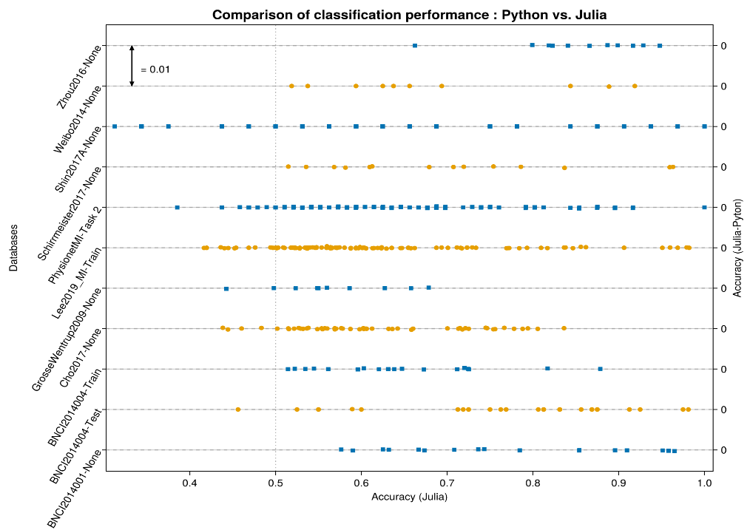

Execution Time
The execution time for performing the above cross-validations has been estimated as the median execution time observed across five repetitions of the whole cross-validation procedure, excluding pre-processing and encoding. Both in the Julia and Python implementation, multithreading has been enabled, allowing four threads to be used in parallel.
Results
1) “right hand” vs “feet”
Table 4: Execution time in milliseconds for “right hand” vs. “feet” MI
Database | Julia Mean and Std (ms) | Python Mean and Std (ms) | Difference (abs)
AlexMI-None | 14 ± 2 | 256 ± 3 | 242
BNCI2014001-None | 114 ± 45 | 437 ± 29 | 323
BNCI2014002-Test | 26 ± 27 | 258 ± 11 | 232
BNCI2014002-Train | 35 ± 11 | 288 ± 26 | 253
BNCI2015001-None | 55 ± 23 | 285 ± 31 | 230
Schirrmeister2017-None | 13454 ± 16005 | 76923 ± 54557 | 63469
Weibo2014-None | 1971 ± 1965 | 4802 ± 2655 | 2956
Zhou2016-None | 38 ± 32 | 283 ± 17 | 245

Figure 3: Execution Time in milliseconds (log₁₀) for “right hand” vs. “feet” MI
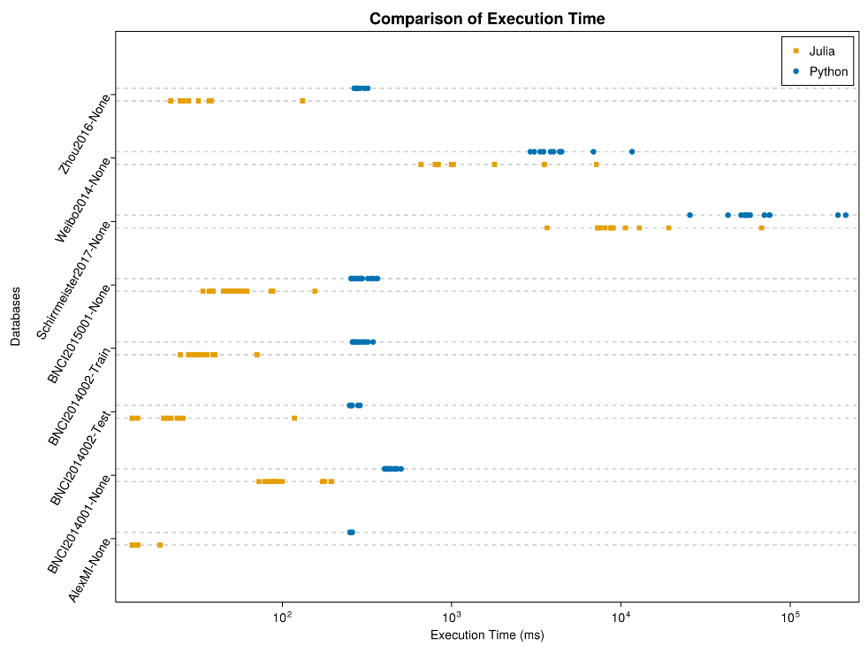

Figure 4: Execution Time (Ratio Python/Julia) for “right hand” vs. “feet” MI
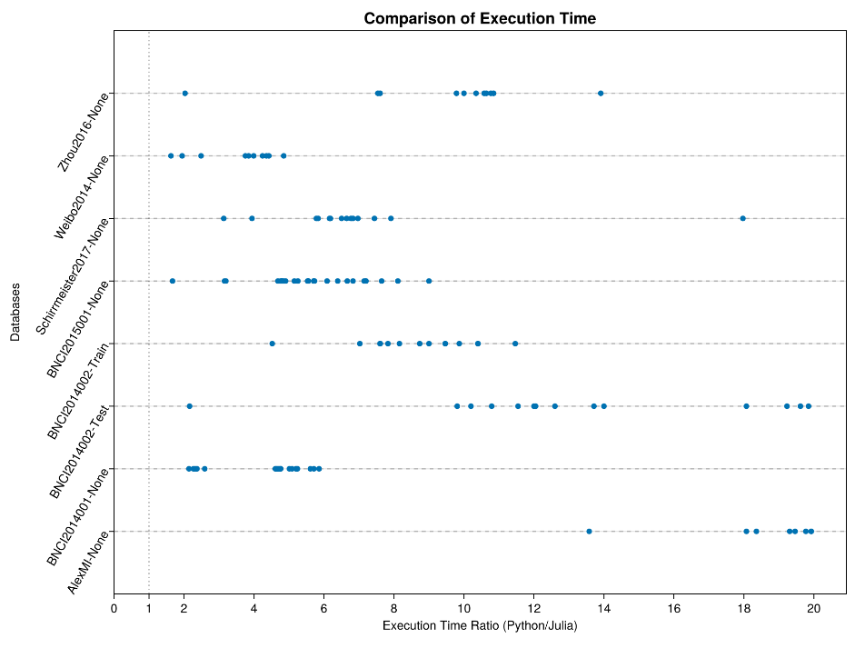

2) “left hand” vs. “right hand”.
Table 5: Execution time in milliseconds for “left hand” vs. “right hand” MI
Database | Julia Mean and Std (ms) | Python Mean and Std (ms) | Difference (abs)
BNCI2014001-None | 109 ± 37 | 406 ± 11 | 296
BNCI2014004-Test | 15 ± 4 | 260 ± 4 | 245
BNCI2014004-Train | 12 ± 3 | 264 ± 8 | 251
Cho2017-None | 943 ± 62 | 4049 ± 269 | 3106
GrosseWentrup2009-None | 3940 ± 375 | 30792 ± 3249 | 26852
Lee2019_MI-Train | 599 ± 104 | 2552 ± 526 | 1953
PhysionetMI-Task | 333 ± 270 | 931 ± 204 | 856
Schirrmeister2017-None | 12647 ± 14830 | 76416 ± 54510 | 63769
Shin2017A-None | 25 ± 8 | 277 ± 11 | 252
Weibo2014-None | 1823 ± 1953 | 4665 ± 2624 | 2842
Zhou2016-None | 37 ± 8 | 273 ± 4 | 236

Figure 5: Execution Time in milliseconds (log₁₀) for “left hand” vs. “right hand” MI
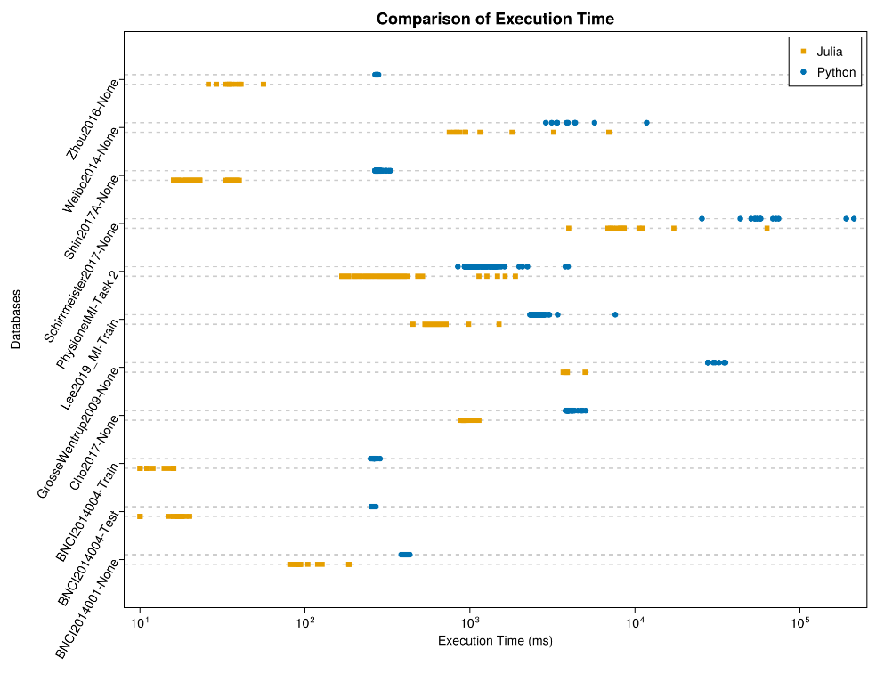

Figure 6: Execution Time (Ratio Python/Julia) for left hand vs. right hand MI

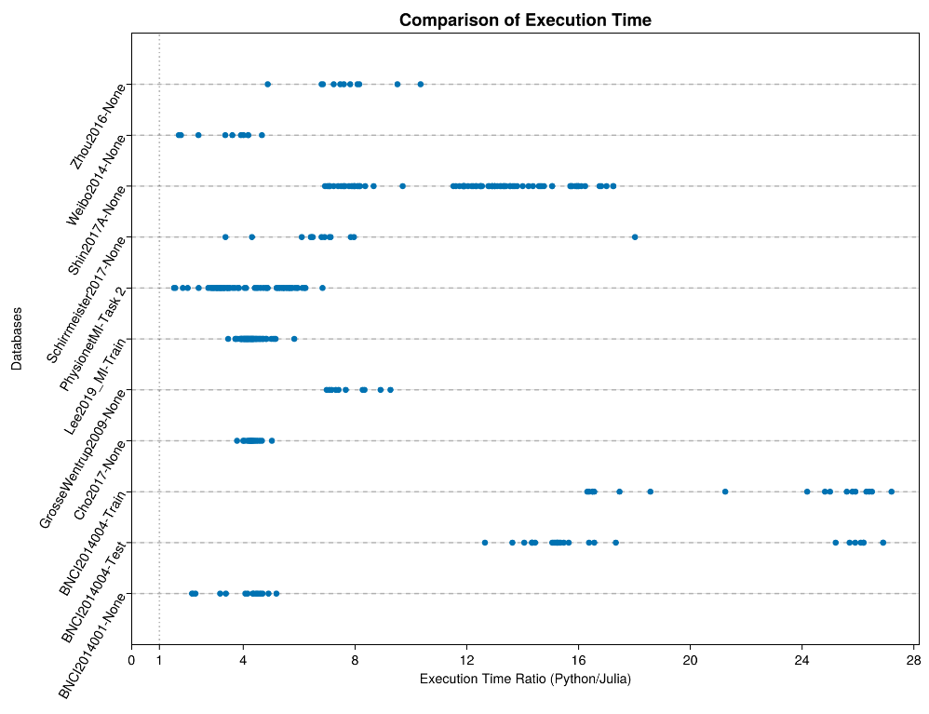

Conclusions
The Julia and Python implementations allows the same accuracy. Typically, the Julia implementation is a few times faster. The speed-up factor with the analyzed data is up to ≈ 27.

